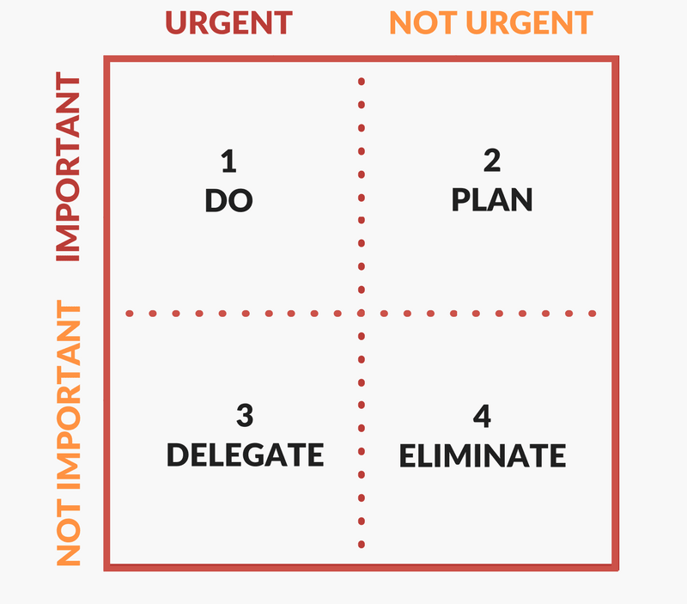

GOALS & STRATEGIC PLANS

DISTRACTIONS

INTERRUPTIONS

CRISES